Renju lesson on September 13, 2001
Hello dear renjuclass people! Welcome to continue study in our nice class! Now we have over 100 members, it is a great group of people. Renjuclass will continue in the usual way. However, there will be some changes in the nearest future. We will keep you informed about all the changes.
Before we go on, I want to thank all the helpers who have been active and supported renjuclass in every way. Let us remind people the names of renjuhelpers. The head of RH team is luwenzhe. Lu, please tell them the names of RH team members. RenjuHelper is shuitaof, RenjuHelper2 is moocheng. Also our great helper ladykayak is here. And ki8 and concord2497. Other two volunteers – heroabro and Bensonla.

Let us begin. Today we will look back at the last world championship. Did you all read jahre’s article about the world championship? It is a nice story. We can discuss about d11 games there because it was the topic of our lessons before we left to vacation. Since you have read the comments of my games from the article from our website, so we will not discuss my games.

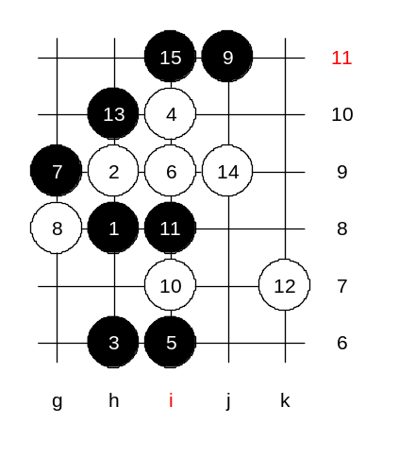
The game we discuss today is Soosyrv – Gardstrom. Round 10. The first 12 moves are quite familiar for you. It is hard to give any sure conclusion about it. Some people claim it is a black sure win, but some people claim it is a white big advantage. Well, there is a small truth in it. It is either black win, or white big advantage. There are no other middle ways. The recent theory has made the game to be so aggressive and sharp, so there is no space for draw games. Today we are not discussing the answer of big question – black or white win. Today we are looking back on last WC and see how people thought and played there. Ants chose 13-h10. It is a nice alternative for traditional 13-j9. The 13th move was new for most players. It surely surprised Ishitani in the first round. But by the next rounds the other players could already prepare themselves. Gardstrom played 14-j9. Move 14-j7 is a fine move, but 14-j9 was a surprise. If 14-f8 then 15-j9 and black is very powerful.
Ants played 15-i11. I am just thinking if that was a wise move.

Remember, the three should be played only if necessary. If we play it too early then we give opponent the extra stone and then we do not have chance for positional play. It is better concept to let white have some activity rather than let white surround blacks. I suggest the idea of L7 and defending for a while. As a result, white attack either fails, or will be killed by counter-threats.
Lets go on. Ants played a three first. About the 16th move, we are not even sure if the 16-j12 was the best. The players with fighting spirit might have played 16-f8. It would give black more open material, but white could rely on counter-attacks and keep active and open game. Now, in the game, the situation after 18th move: White is taking over the positional control. Mostly because of weak three at i11. Note that the i11 three would have been good only in case of direct attack. Now white has an activity and control at all sides. If black didn’t play the i11 then white could have activity, but surely some areas would remain out of white’s control, and black could put its hopes on that.
Black is quite hopeless now in positional concept. Unless black finds a magic way to win in few moves, black will be in trouble soon. I think Ants had realized that black attack had failed. Now he focused on securing the position as well as possible. The 20-g7 was a logical answer. Ants chose passive j7 block. I have a question. Could black have played 21-e7 and 23-h5? Note that 21-h7 is weaker than 21-j7 because on both cases white would block at h5, and then the h7 stone is totally out of game and white j-line still alive. Well, you can make some analysis later about it. Ants’ concept was to balance the game and he didn’t want to gamble before the end of tournament, especially when he needed to get surely to top 7.
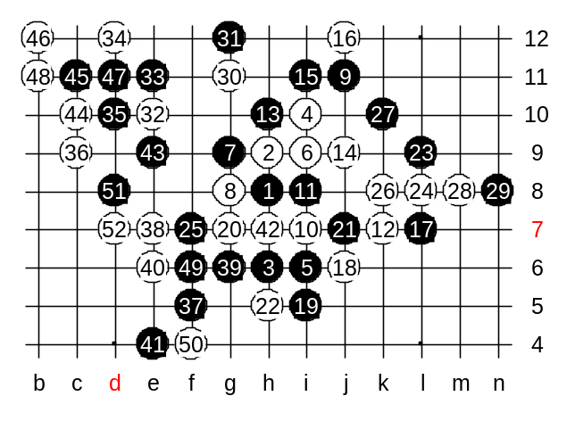
Lets quickly review the further moves, see if anything interesting. Wow, the 26th move was surprising again. So active, and a bit risky. Probably, Petter had counted on controls and played it. 30 is a positional move. It cuts the black forces of left and upper sides. And it is a but space move, to continue white development as well. It also makes the white diagonal line to g12 point alive. I think black could have been more aggressive after that. But probably Ants had made a sure decision of playing safely. The following moves are not best for either side. Black should have taken the f5 and e4 space-points as early as possible. But after white had gotten e10 and c9 stones, the lower side attack did not look so promising for black anymore. I have to remind here that I am making the comments here based on the game record we have. We just can hope it matches with actual situation in their game.
Now, before the end, Ants had finally decided to be active. But it may have been a bad choice. Now the activity causes trouble only. Finally black has defended well.
The game record shows white win after 52nd move. Huh? This is ridiculous. Probably, the organizers had not continued this game input.
Please agree that the game records are really confusing and we do not know the whole truth about it.

The homework questions will be published on website later.

